Nandida Valsaraj

2.

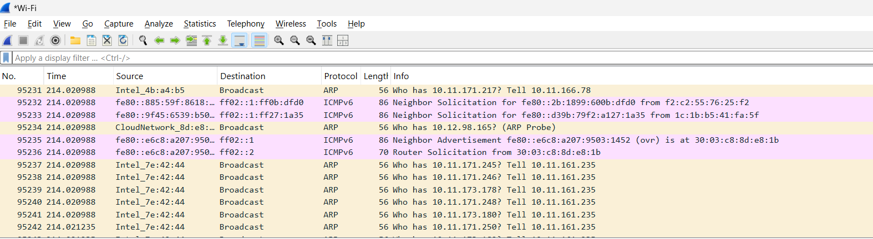

5.

HTTP



DNS

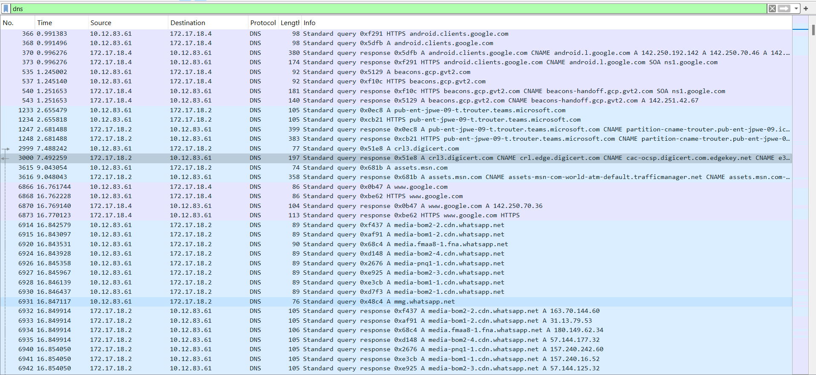

TCP

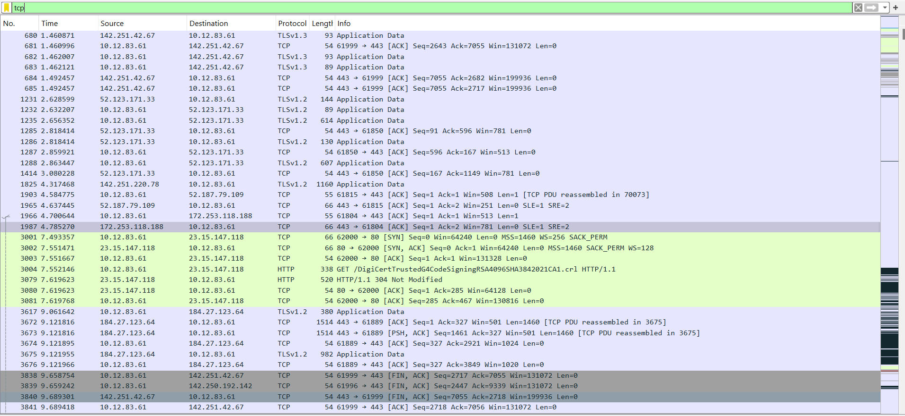

6.

* ICMPv6: (Internet Control Message Protocol version 6) is a crucial protocol for IPv6 networks, serving as a diagnostic and error reporting tool.
* DHCPv6: (Dynamic Host Configuration Protocol for IPv6) is used to automatically assign IPv6 addresses and other network configuration parameters to devices on a network.
* TLSv1.2: a widely used encryption protocol that secures communication over networks, particularly for web browsing and other data transfers.
* TCP: Transmission Control Protocol, a fundamental communication standard within the TCP/IP protocol suite, enabling reliable and ordered delivery of data between applications over a network
* DNS: (Domain Name System) protocol is a fundamental part of the internet that translates human-readable domain names (like www.example.com) into the numerical IP addresses that computers use to locate each other.

7.



8. Wireshark can be used for capturing network packets and analysing them. It can help in network diagnosis and understanding traffic flow and attacks. It can capture from all interfaces and all type of network packets, which makes it easy for network administrator to monitor complete network.